44.57: From Pr.(44.56):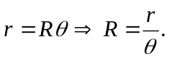
So 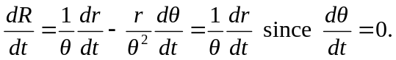
So 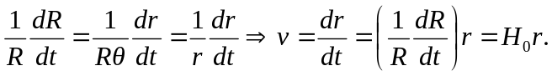
Now 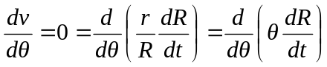
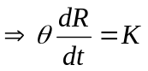 where  is a constant.
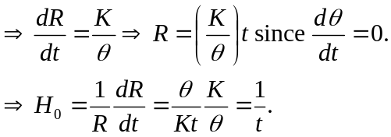
So the current value of the Hubble constant is 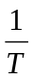where T is the present age of the universe.

